UPISHIELD: FRAUD DETECTION AND BEHAVIOR ANALYTICS IN REAL-TIME PAYMENT SYSTEMS
ABSTARCT
In recent years, the rapid growth of Unified Payments Interface (UPI) transactions in India has significantly transformed the digital payment ecosystem, with the National Payments Corporation of India (NPCI) reporting over 14 billion transactions in a single month of 2024, reflecting both the convenience and the increased risk of fraudulent activities. This project addresses the critical challenge of automatically classifying UPI transaction descriptions into multiple categories, including fraud detection and transaction type classification, using advanced Natural Language Processing (NLP) and machine learning techniques. Traditionally, manual fraud detection and classification involve human review of transaction logs, keyword matching, and cross-verification with known fraud patterns—a process that is time-consuming, prone to human error, and incapable of processing large-scale, real-time data. These manual systems suffer from limitations such as delayed detection, low scalability, and inconsistent accuracy due to subjective judgment. The motivation for this research stems from the pressing need for automated, scalable, and accurate systems that can process high volumes of transactional data with minimal latency. The proposed system utilizes Python-based NLP preprocessing, Sentence-BERT embeddings for semantic feature representation, and an ensemble of classification algorithms including Naive Bayes variants and HistGradientBoostingClassifier, with class imbalance addressed through SMOTE oversampling. It is capable of multi-output classification, producing both fraud and transaction type predictions simultaneously, with detailed performance evaluation through confusion matrices and classification reports. By automating this process, the system ensures higher accuracy, faster processing, and adaptability to evolving transaction patterns. The outcome is a scalable, reusable, and interpretable model pipeline that can be integrated into banking or fintech platforms, paving the way for real-time fraud prevention and improved financial security in the digital payment ecosystem.

CHAPTER 1
INTRODUCTION
1.1 Overview
The way we handle monetary transactions has been revolutionized by the fast development of technology and the widespread availability of digital payment solutions. There has been an upsurge in digital payment fraud with the increased use of digital payment methods [1]. The safety and reliability of online financial transactions are constantly being threatened by cybercriminals who develop new methods of exploiting loopholes in payment systems. This paper aims to examine, in the context of the digital era and Industry 4.0, the different approaches used to detect and combat digital payment fraud. This research’s overarching goal is to better understand the threats to digital payment systems and devise solutions to counter them. Understanding the many different types of fraudulent activity that may occur with digital payment systems is essential for grasping the function that fraud detection serves in the current age [2]. Examples include things like identity theft, account takeovers, phishing, malware attacks, and so on and so forth. This kind of fraudulent conduct may severely impact individual consumers, businesses, and financial institutions [3]. Some of the negative effects that may result from such actions include financial losses, damage to a brand, and a drop in a customer’s faith in a business. Artificial intelligence (AI), and big data analytics are some examples of digital technologies that are a part of the fourth industrial revolution (Industry 4.0). This transformation has introduced both new opportunities and new challenges in the area of fraud detection. AI and big data analytics are some examples of these digital technologies [4]. These technologies make enormous quantities of data accessible, and they also provide strong analysis tools, which enable the immediate identification of patterns, anomalies, and suspicious activities. For fraud detection systems to be effective, they need to be able to deal with the increased risks and complexities caused by introducing new technologies [5].
1.2 Problem Defination
With the exponential growth of textual data generated from social media, customer reviews, news articles, and other digital platforms, organizations face significant challenges in efficiently processing, analyzing, and extracting meaningful insights from this information. Traditional machine learning models often struggle with large-scale and unbalanced datasets, while deep learning models require substantial computational resources and well-preprocessed data to perform optimally. Additionally, integrating multiple approaches—such as classical ML, deep learning, and transformer-based architectures—into a single, modular, and scalable pipeline is a complex task. This project addresses these challenges by developing a comprehensive NLP and machine learning framework that seamlessly handles preprocessing, visualization, model training, evaluation, and deployment, ensuring adaptability to various text analytics use cases.
1.3 Research Motivation
The National Payments Corporation of India (NPCI) reports billions of monthly UPI transactions, and even a small percentage of fraud can lead to massive financial losses. Existing manual review systems are slow, error-prone, and costly, while traditional keyword-based algorithms struggle to handle complex, contextual transaction descriptions. The motivation for this research lies in harnessing the power of Natural Language Processing (NLP) and machine learning to develop a system that can automatically process large-scale data, detect suspicious patterns, and adapt to changing fraud tactics, thereby improving security, reducing losses, and building trust in digital payment ecosystems. Fraudsters are exploiting transaction descriptions to disguise malicious activities — using deceptive wording, fake merchant names, or misleading references that bypass traditional keyword filters. Manual review teams in banks and fintech companies struggle to keep up with the sheer scale of transactions, resulting in delayed detection, overlooked anomalies, and higher operational costs.Existing fraud detection systems often rely on rule-based algorithms, which are rigid and unable to adapt to new fraud tactics. These systems fail to capture linguistic nuances, slang, or evolving fraud patterns that human fraudsters intentionally embed in descriptions to evade detection.
1.4 Research Objectives
- To design and implement a modular NLP and ML framework that supports data preprocessing, visualization, model training, and evaluation.
- To integrate classical machine learning algorithms, deep learning architectures, and transformer-based models for comprehensive text analytics.
- To address the issue of imbalanced datasets using oversampling techniques such as SMOTE.
- To provide visualization capabilities for training results, performance metrics, and text-based insights.
- To ensure the framework is scalable, maintainable, and easily adaptable for various NLP applications.
  - Significance
- Early Detection and Prevention - Enables timely identification of Otitis Media in its early stages, reducing the risk of complications such as hearing loss and chronic infections.
- Reduction in Human Error - Minimizes misdiagnosis by providing consistent and objective diagnostic results compared to manual examination by healthcare practitioners.
- Improved Accessibility - Allows remote diagnosis, benefiting rural and underserved areas where specialized ENT doctors are not readily available.
- Time and Cost Efficiency - Speeds up the diagnostic process, reducing consultation time and lowering healthcare costs for both patients and providers.
- Integration with Telemedicine - Can be integrated into telemedicine platforms, enabling online consultations with AI-assisted diagnostic support.
- Scalable Healthcare Solution - Once trained, the AI model can handle large volumes of otoscopic images, making it suitable for mass screening programs.
- Educational and Training Tool - Acts as a learning aid for medical students and junior doctors to understand diagnostic features of ear infections.
1.6 Applications
- Sentiment Analysis – Classifying opinions in product reviews, social media posts, and customer feedback.
- Text Classification – Categorizing documents, news articles, and reports into predefined categories.
- Spam Detection – Filtering spam or fraudulent messages from email and messaging platforms.
- Healthcare – Analyzing patient records, medical reports, and clinical trial documents for insights.
- Finance – Detecting fraudulent activities and analyzing financial news for market prediction.
- Customer Support – Automating ticket categorization and prioritization in support systems.
- Content Moderation – Detecting hate speech, harmful content, or misinformation online.

CHAPTER 2
LITERATURE SURVEY
Ms. Kishori Dhanaji Kadam et al[6]. proposed a robust UPI fraud detection system employing advanced machine learning techniques to enhance the security of digital transactions. They proposed system leverages a diverse set of features, including transactional patterns, user behaviour, and device information, to create a comprehensive model for fraud detection. Machine learning algorithms, such as supervised learning classifiers and anomaly detection techniques, are employed to analyse historical transaction data and identify patterns indicative of fraudulent activities. The model is trained on a labelled dataset that includes both genuine and fraudulent transactions, ensuring its ability to distinguish between normal and suspicious behaviour.
Chang V et al[7]. compared the efficacy of two approaches, random under-sampling and oversampling, using the synthetic minority over-sampling technique (SMOTE). Random under-sampling aims for fairness by excluding examples from the majority class, but this compromises precision in favor of recall. To strike a balance and ensure statistical significance, SMOTE was used instead to produce artificial examples of the minority class. Based on the data obtained, it is clear that random under-sampling achieves high recall (92.86%) at the expense of low precision, whereas SMOTE achieves a higher accuracy (86.75%) and a more even F1 score (73.47%) at the expense of a slightly lower recall. As true fraudulent transactions require at least two methods for verification, we investigated different machine learning methods and made suitable balances between accuracy, F1 score, and recall. Our comparison sheds light on the subtleties and ramifications of each approach, allowing professionals in the field of cybersecurity to better choose the approach that best meets the needs of their own firm.
Abd Razak S et al[8]. attempted to present a systematic literature review (SLR) that systematically reviews and synthesizes the existing literature on machine learning (ML)-based fraud detection. Particularly, the review employed the Kitchenham approach, which uses well-defined protocols to extract and synthesize the relevant articles; it then report the obtained results. Based on the specified search strategies from popular electronic database libraries, several studies have been gathered. After inclusion/exclusion criteria, 93 articles were chosen, synthesized, and analyzed. They reviewed summarizes popular ML techniques used for fraud detection, the most popular fraud type, and evaluation metrics. They reviewed articles showed that support vector machine (SVM) and artificial neural network (ANN) are popular ML algorithms used for fraud detection, and credit card fraud is the most popular fraud type addressed using ML techniques.
AbouGrad H et al[9]. explored a decentralized anomaly detection framework using deep autoencoders, designed to meet the dual imperatives of fraud detection effectiveness and user data privacy. Instead of relying on centralized aggregation or data sharing, the proposed model simulates distributed training across multiple financial nodes, with each institution processing data locally and independently. The framework is evaluated using two real-world datasets, the Credit Card Fraud dataset and the NeurIPS 2022 Bank Account Fraud dataset. The research methodology applied robust preprocessing, the implementation of a compact autoencoder architecture, and a threshold-based anomaly detection strategy. Evaluation metrics, such as confusion matrices, receiver operating characteristic (ROC) curves, precision–recall (PR) curves, and reconstruction error distributions, are used to assess the model’s performance. Also, a threshold sensitivity analysis has been applied to explore detection trade-offs at varying levels of strictness.
Abbassi H et al[10]. represented of transactions, serving in abnormality detection. On the other hand, QLSTM combines quantum computational capability with temporal sequence modeling, seeking to give a rapid and scalable method for real-time malignancy detection. The designed approach was set up through TensorFlow Federated on two real-world datasets—notably IEEE-CIS and European cardholders—outperforming current strategies in terms of accuracy and sensitivity, achieving 94.5% and 91.3%, respectively.
Binsawad M et al[11]. introduced the Voted Perceptron (VP) model, which utilizes an iterative learning process to dynamically adapt decision boundaries based on misclassified examples. In contrast to traditional models with static decision rules, the VP model constantly updates its weight parameters, thus providing better fraud detection abilities. The evaluation compares VP with state-of-the-art machine learning models, such as Average One Dependency Estimator (A1DE), K-nearest Neighbor (KNN), Naïve Bayes (NB), Random Tree (RT), and Functional Tree (FT), by using important performance metrics, like Mean Absolute Error (MAE), Root Mean Square Error (RMSE), True Positive Rate (TPR), recall, and accuracy. Experimental results show that VP outperforms its rivals significantly, yielding better fraud detection performance with low error rates and high recall. Furthermore, an ablation study confirms the influence of essential VP model elements on general classification performance.
Abbassi H et al[12]. suggested architecture builds on the adeptness of VAE-QLSTM to capture meaningful representations of transactions, serving in abnormality detection. On the other hand, QLSTM combines quantum computational capability with temporal sequence modeling, seeking to give a rapid and scalable method for real-time malignancy detection. They designed approach was set up through TensorFlow Federated on two real-world datasets—notably IEEE-CIS and European cardholders—outperforming current strategies in terms of accuracy and sensitivity, achieving 94.5% and 91.3%, respectively.
Oztemel E et al[13]. prevented possible fraud operations, banks generally use rule-based techniques or analytical models. In this respect, analytical models have an important place due to their effectiveness, performance, and fast response. The main aim of therefore to enhance the theoretical and practical understanding of credit card fraud operations, review basic approaches, and propose a more comprehensive approach utilizing the agents. Note that in this study, static analytic modelling (existing approaches) and dynamic analytic modelling (emerging approaches) techniques are compared in terms of methodology, performance, and respective approaches. Since fraud methods and transactions are constantly changing over time, it is thought that there will be an increase in the use of agent-based models with dynamic analytical capabilities.
Yaseen H et al[14]. concludes with suggestions for practical implementation by banks, developers, and regulators to align AI deployment with ethical and regulatory aspirations. It recommends transparent, explainable, and fairness-sensitive AI tools as essential for promoting adoption in regulation-driven sectors. The findings provide a guide for promoting responsible, trust-driven AI implementation in fraud detection.
Sun Q et al[15]. proposed any effective method or engineering implementation. In this article, an extension to boost algorithms is presented that permits the incorporation of prior human knowledge as a means of compensating for a training data shortage and improving prediction results. Prior human knowledge is accumulated from historical fraud transactions or transferred from different domains in the form of expert rules and blacklists. The knowledge is applied to extract risk features from transaction data, risk features together with normal features are input into the boosting algorithm to perform training, and therefore we incorporate boosting algorithm with prior human knowledge to improve the performance of the model. For the first time we verified the effectiveness of the method via a widely deployed mobile APP with 150+ million users, and by taking experiments on a certain dataset, the extended boosting model shows an accuracy increase from 0.9825 to 0.9871 and a recall rate increase from 0.888 to 0.948.
Sathupadi K et al[16]. introduced BankNet, a predictive analytics framework integrating big data tools and a BiLSTM neural network to deliver high-accuracy transaction analysis. BankNet achieves exceptional predictive performance, with a Root Mean Squared Error of 0.0159 and fraud detection accuracy of 98.5%, while efficiently handling data rates up to 1000 Mbps with minimal latency. By addressing critical challenges in fraud detection and operational efficiency, BankNet establishes itself as a robust decision support system for modern Internet banking. Its scalability and precision make it a transformative tool for enhancing security and trust in financial services.
Abd Razak S et al[17]. attempted to present a systematic literature review (SLR) that systematically reviews and synthesizes the existing literature on machine learning (ML)-based fraud detection. Particularly, the review employed the Kitchenham approach, which uses well-defined protocols to extract and synthesize the relevant articles; it then report the obtained results. Based on the specified search strategies from popular electronic database libraries, several studies have been gathered. After inclusion/exclusion criteria, 93 articles were chosen, synthesized, and analyzed. They reviewed summarizes popular ML techniques used for fraud detection, the most popular fraud type, and evaluation metrics. They reviewed articles showed that support vector machine (SVM) and artificial neural network (ANN) are popular ML algorithms used for fraud detection, and credit card fraud is the most popular fraud type addressed using ML techniques.
Chang V et al[18]. compared the efficacy of two approaches, random under-sampling and oversampling, using the synthetic minority over-sampling technique (SMOTE). Random under-sampling aims for fairness by excluding examples from the majority class, but this compromises precision in favor of recall. To strike a balance and ensure statistical significance, SMOTE was used instead to produce artificial examples of the minority class. Based on the data obtained, it is clear that random under-sampling achieves high recall (92.86%) at the expense of low precision, whereas SMOTE achieves a higher accuracy (86.75%) and a more even F1 score (73.47%) at the expense of a slightly lower recall. As true fraudulent transactions require at least two methods for verification, we investigated different machine learning methods and made suitable balances between accuracy, F1 score, and recall.
Abbassi H et al[19]. provided a unique approach to tackling those challenges by integrating VAE-QLSTM with Federated Learning (FL) in a semi-decentralized architecture, maintaining privacy alongside adapting to emerging malicious behaviors. They suggested architecture builds on the adeptness of VAE-QLSTM to capture meaningful representations of transactions, serving in abnormality detection. On the other hand, QLSTM combines quantum computational capability with temporal sequence modeling, seeking to give a rapid and scalable method for real-time malignancy detection. The designed approach was set up through TensorFlow Federated on two real-world datasets—notably IEEE-CIS and European cardholders—outperforming current strategies in terms of accuracy and sensitivity, achieving 94.5% and 91.3%, respectively.
Chu L et al[20]. introduces a novel intelligent financial fraud detection support system, leveraging a three-level relationship penetration (3-LRP) method to decode complex fraudulent networks and enhance prediction accuracy, by integrating the fuzzy rough density-based feature selection (FRDFS) methodology, which optimizes feature screening in noisy financial environments, together with the fuzzy deterministic soft voting (FDSV) method that combines transformer-based deep tabular networks with conventional machine learning classifiers. The integration of FRDFS optimizes feature selection, significantly improving the system’s reliability and performance. An empirical analysis, using a real financial dataset from Chinese small and medium-sized enterprises (SMEs), demonstrates the effectiveness of our proposed method.
Theodorakopoulos L et al[21]. discussed challenges like overfitting, data access, and real-time implementation with potential solutions such as ensemble methods, intelligent sampling, and graph-based approaches. Future directions are underlined by deploying these frameworks in live transaction environments, leveraging continuous learning mechanisms, and integrating advanced anomaly detection techniques to handle evolving fraud patterns. They present research demonstrates the importance of distributed machine learning frameworks for developing robust, scalable, and efficient fraud detection systems, considering their significant impact on financial security and the overall financial ecosystem.
AbouGrad H et al[22]. explored a decentralized anomaly detection framework using deep autoencoders, designed to meet the dual imperatives of fraud detection effectiveness and user data privacy. Instead of relying on centralized aggregation or data sharing, the proposed model simulates distributed training across multiple financial nodes, with each institution processing data locally and independently. The framework is evaluated using two real-world datasets, the Credit Card Fraud dataset and the NeurIPS 2022 Bank Account Fraud dataset. The methodology applied robust preprocessing, the implementation of a compact autoencoder architecture, and a threshold-based anomaly detection strategy. Evaluation metrics, such as confusion matrices, receiver operating characteristic (ROC) curves, precision–recall (PR) curves, and reconstruction error distributions, are used to assess the model’s performance. Also, a threshold sensitivity analysis has been applied to explore detection trade-offs at varying levels of strictness.
Aljunaid SK et al[23]. proposed model is trained on a financial fraud detection dataset, and the results highlight the efficiency of detection and successful elimination of false positives and contribute to the improvement of the existing models as the proposed model attained 99.95% accuracy and a miss rate of 0.05%, paving the way for a more effective and comprehensive AI-based system to detect potential fraudulence in banking.
Golightly L et al[24]. investigated different machine learning methods and made suitable balances between accuracy, F1 score, and recall. Our comparison sheds light on the subtleties and ramifications of each approach, allowing professionals in the field of cybersecurity to better choose the approach that best meets the needs of their own firm. They highlights the need to resolve class imbalances for effective fraud detection in cybersecurity, as well as the need for constant monitoring and the investigation of new approaches to increase applicability.
Abbassi H et al[25]. provided a unique approach to tackling those challenges by integrating VAE-QLSTM with Federated Learning (FL) in a semi-decentralized architecture, maintaining privacy alongside adapting to emerging malicious behaviors. They suggested architecture builds on the adeptness of VAE-QLSTM to capture meaningful representations of transactions, serving in abnormality detection. On the other hand, QLSTM combines quantum computational capability with temporal sequence modeling, seeking to give a rapid and scalable method for real-time malignancy detection.

CHAPTER 3
TRADITIONAL SYSTEM
In the earliest and most traditional setup for UPI transaction monitoring, the process was entirely manual and rule-driven, without any automated statistical modeling or machine learning. Transaction data would be extracted from payment logs and organized into spreadsheets or database tables. Analysts or operations teams would apply a set of predefined rules to detect suspicious activity or classify transactions. These rules were often derived from regulatory guidelines, compliance policies, and the experience of fraud investigation teams. For example, a transaction could be flagged if its amount exceeded a certain threshold, if it occurred at unusual times (e.g., late night), if it originated from a blocked or suspicious account, or if it involved high-risk merchant categories. Merchant codes and transaction categories were assigned manually or through fixed lookup tables. Text descriptions of payments were either ignored or manually scanned by staff for keywords indicating unusual behavior. Alerts and reports were compiled manually, and any detected fraud cases were escalated to investigation teams for further review. This process was entirely dependent on human oversight and predefined conditions, making it slow, rigid, and resource-intensive.
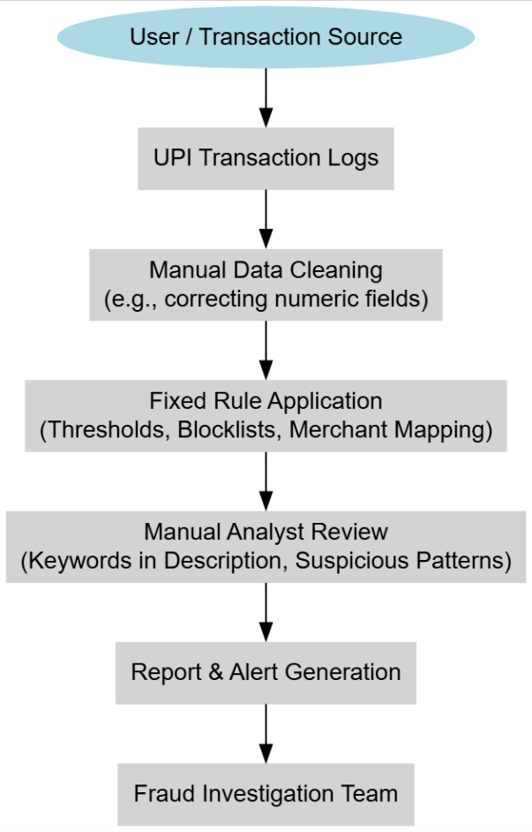
Fig. 3.1: Traditional system architecture.
Limitations of the Traditional Manual System
- Time-Consuming: Every transaction check required manual review or simple rule application, slowing down fraud detection.
- Reactive, Not Proactive: Could only catch fraud patterns that were already known and documented; failed to detect new or evolving fraud schemes.
- High Human Error Risk: Manual checks depended on individual judgment, which could lead to inconsistent results and oversight.
- No Deep Text Analysis: Transaction descriptions were either ignored or superficially scanned, missing hidden indicators of fraud.
- Fixed, Hardcoded Rules: Inflexible system that required manual updating of rules whenever new fraud types emerged.
- Low Scalability: As transaction volume grew, manual review became unmanageable without drastically increasing staff.
- Delayed Response: Fraudulent transactions could take hours or days to be identified, allowing further fraudulent activity to occur before intervention.
- Minimal Data Utilization: Relied on a limited set of structured data fields, wasting the potential of richer transaction metadata.

CHAPTER 4
PROPOSED SYSTEM
4.1 Overview
The proposed methodology introduces a hybrid multi-output classification framework that simultaneously predicts transaction type and fraud status by integrating semantic text embeddings, structured feature processing, and imbalance-aware learning within a single pipeline. Unlike the traditional/manual systems that rely on static rules and purely structured numeric data, and unlike surveyed ML approaches that address only one prediction task or one data type at a time, this method combines Sentence-BERT (Numerical SBERT) embeddings for contextual language understanding, numeric feature integration for structured data, Synthetic Minority Over-sampling Technique (SMOTE) for class balancing, and multi-output model training for concurrent predictions. This combination has not been reported in existing surveys, making it a novel unified approach. It directly addresses key drawbacks of prior methods by enabling the model to learn from both unstructured and structured information, adapt to evolving patterns without manual rule updates, and handle severe class imbalance effectively.
Step-1: Data Acquisition and Representation
The system begins by collecting transaction data containing both structured attributes (amount, age groups, timestamps, merchant identifiers) and unstructured attributes (transaction descriptions, remarks). All features are preserved to avoid information loss, ensuring that both numeric trends and linguistic cues are available for learning.
Step-2: Preprocessing and Data Normalization
Structured fields are cleaned by handling missing values according to their type, while age group information is decomposed into numerical lower and upper bounds to retain quantitative meaning. Unstructured text undergoes a cleaning process that includes normalization, removal of irrelevant characters, elimination of stopwords, and lemmatization to reduce linguistic variability.
Step-3: Semantic Feature Extraction
The processed text is transformed into dense semantic vectors using Numerical SBERT. This step captures deep contextual meaning, enabling the system to detect subtle fraud indicators and transaction type patterns that static keyword-based or rule-driven approaches miss. Unlike older embedding methods, Numerical SBERT generates context-sensitive representations that can differentiate between superficially similar but semantically distinct transaction notes.
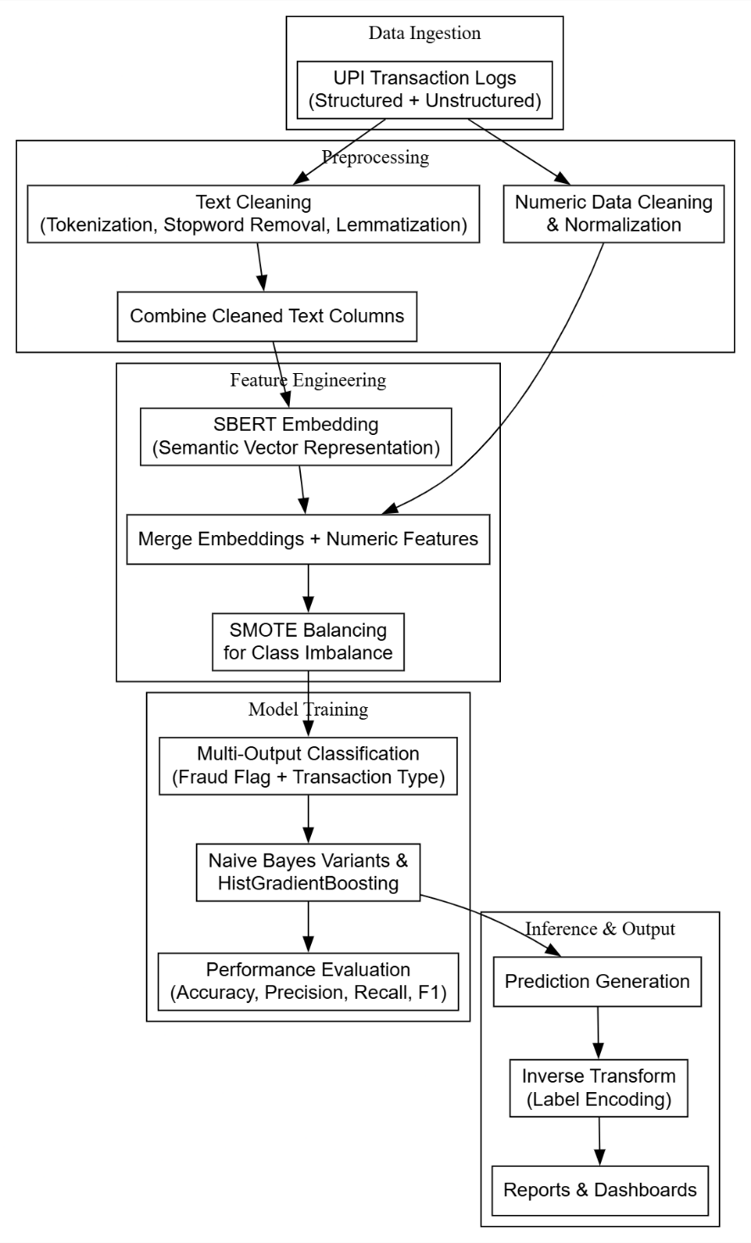
Fig. 4.1: Proposed block diagram of fraud detection and behaviour analytics in real time payment systems.
Step-4: Feature Fusion
The semantic vectors from Numerical SBERT are concatenated with the cleaned numerical features, producing a unified multi-modal feature space. This fusion allows the model to reason jointly over numeric trends (e.g., unusually high amounts) and textual semantics (e.g., suspicious note descriptions), creating a richer decision-making foundation.
Step-5: Imbalance Handling with SMOTE
Since fraudulent transactions are rare compared to normal ones, the combined dataset is balanced using SMOTE. This oversampling method synthetically generates realistic samples of minority classes in both prediction targets, preventing the classifier from becoming biased toward majority classes and improving its ability to detect rare but critical fraud cases.
Step-6: Multi-Output Model Training
Two related classification tasks — fraud detection and transaction type classification — are trained concurrently using the same feature set. By treating them as related but separate outputs, the system benefits from shared feature learning while still tailoring decision boundaries for each task. Models such as ensemble gradient boosting classifiers are applied, which can handle complex non-linear relationships across both numeric and semantic inputs.
Step-7: Evaluation and Metrics Analysis
Model predictions are evaluated using comprehensive metrics including accuracy, precision, recall, and F1-score for each output. This ensures that performance is measured not only by overall correctness but also by its ability to correctly identify minority classes, directly addressing the precision–recall trade-off often ignored in traditional systems.
Step-8: Deployment and Adaptability
The trained multi-output model can be deployed to process incoming UPI transactions in real time, producing both fraud risk labels and transaction category predictions. Unlike traditional rule-based systems, it adapts automatically to new patterns as long as it is retrained with updated data, eliminating the need for frequent manual rule rewriting.
4.2 NLP Preprocessing
NLP preprocessing is a critical step that transforms raw unstructured text data into a clean, semantically meaningful representation suitable for machine learning. Real-world transaction descriptions often contain inconsistencies, irrelevant characters, variations in word forms, and stopwords that do not contribute to fraud detection or transaction type classification. By systematically cleaning and standardizing this text data, the model can focus on meaningful linguistic patterns that indicate transaction behavior or potential fraud. This step ensures that semantic embeddings generated later (e.g., Numerical SBERT) capture the true contextual meaning rather than noise.
Step 1: Lowercasing
All text is converted to lowercase to ensure uniformity. Transaction descriptions may have inconsistent capitalization, and models are generally case-sensitive. By lowering all text, words like “Payment” and “payment” are treated identically, preventing duplicate feature representations and improving consistency in downstream embedding.
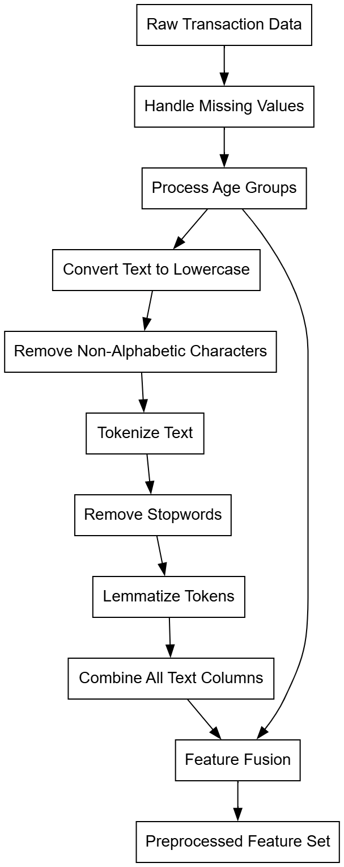
Fig. 4.3: Block diagram of NLP preprocessing.
Step 2: Removal of Non-Alphabetic Characters
Special characters, punctuation, numbers, and symbols are removed from the text. Transaction logs may contain extraneous characters such as #, $, or timestamps. These do not carry meaningful semantic information for fraud detection and can mislead the model if included. Only alphabetic characters and spaces are retained to preserve the structure of meaningful words.
Step 3: Tokenization
The cleaned text is split into individual words (tokens). Tokenization allows the model to process the text as discrete units, which is essential for semantic embedding generation. Each token represents a basic unit of meaning, enabling subsequent filtering and lemmatization steps.
Step 4: Stopword Removal
Common English words such as “the,” “is,” “and,” or “at” are removed. These words are ubiquitous and carry little discriminative information regarding transaction type or fraud. Eliminating them reduces noise and focuses the model on words that carry meaningful signals, improving both computational efficiency and embedding quality.
Step 5: Lemmatization
Each token is reduced to its base or dictionary form using lemmatization. For example, “sending,” “sent,” and “sends” are all converted to “send.” This step reduces vocabulary size, consolidates semantically similar words, and ensures that contextually identical terms do not create redundant features. Unlike stemming, lemmatization preserves the actual word meaning, which is crucial for semantic embeddings like Numerical SBERT.
Step 6: Combining Text Columns
If multiple text columns exist in the dataset (e.g., transaction remarks, additional notes), they are merged into a single combined text feature. This unified representation ensures that the model captures all available contextual information, allowing semantic embeddings to learn patterns across different textual sources instead of treating them independently.
Step 7: Output for Feature Fusion
The cleaned and combined text becomes part of the unified feature set, which is later fused with numerical features. This step ensures that both structured numeric trends (e.g., amounts, age ranges) and unstructured semantic signals contribute simultaneously to downstream multi-output classification.
4.3 EDA Plots
Exploratory Data Analysis (EDA) is a critical step in understanding the underlying patterns and distributions within a dataset before applying any predictive modeling techniques. For transaction datasets in fraud detection, EDA helps identify class imbalances, skewed distributions, and potential biases in the data. Visualizing the target variables provides insights into the relative frequencies of different classes and informs subsequent preprocessing steps, such as oversampling, feature weighting, or stratified splitting. By examining both the fraud_flag and transaction_type, analysts can ensure that the dataset is properly balanced and representative of real-world scenarios.
Fraud Flag Distribution
The fraud flag distribution plot depicts the proportion of fraudulent versus non-fraudulent transactions. In typical transaction datasets, fraudulent transactions are much less frequent than legitimate ones, creating a significant class imbalance. This visualization highlights the severity of the imbalance, which is important for model selection and evaluation. For instance, relying solely on accuracy as a performance metric could be misleading, as a model predicting all transactions as non-fraudulent might achieve high accuracy while failing to detect actual fraud cases. The plot motivates the use of techniques such as SMOTE, class weighting, or other oversampling strategies to improve the model’s ability to detect minority fraud instances.
Transaction Type Distribution
The transaction type distribution plot shows the frequency of each category of transaction, such as peer-to-peer transfers, bill payments, or merchant payments. Uneven representation of transaction types can introduce bias into the classification model, where the model may perform well for majority categories but poorly for underrepresented types. By visualizing these distributions, analysts can identify which transaction types may require additional data collection, augmentation, or targeted sampling to ensure that the model learns patterns across all categories. This plot is also crucial for multi-output modeling, as predicting both fraud and transaction type accurately requires balanced exposure to all types.
4.4 Feature Extraction
Feature extraction is a vital process in machine learning that transforms raw data into meaningful representations suitable for model training. In the context of UPI transaction analysis, the data contains both structured numeric fields (amounts, timestamps, age ranges) and unstructured textual descriptions. A robust feature extraction pipeline must integrate both types of information, enabling the model to learn subtle patterns for fraud detection and transaction type classification. The proposed methodology combines semantic text embeddings from Numerical SBERT with cleaned numeric features to create a unified, multi-modal feature space.
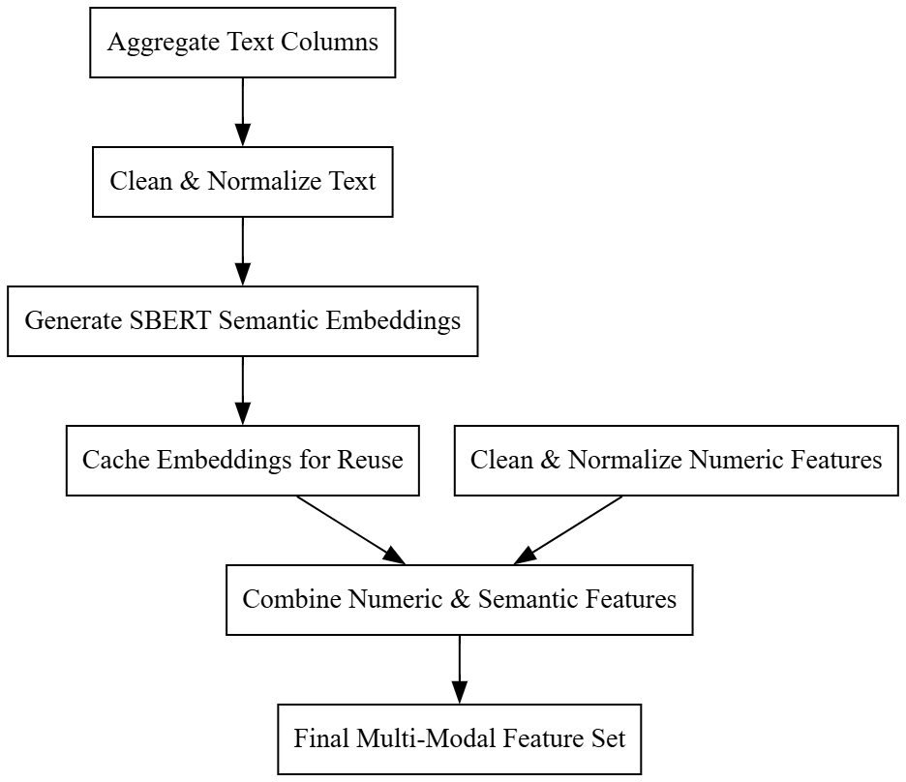
Fig. 4.4: Block diagram of numerical SBERT Feature extraction.
Step-1: Text Aggregation and Preprocessing
The first step involves aggregating all relevant textual columns into a single combined field. This ensures that every piece of textual information—from transaction remarks to descriptions—is preserved and contributes to the final feature representation. Preprocessing cleans the text by removing irrelevant characters, normalizing the language, and eliminating stopwords. This step reduces noise and prepares the text for semantic embedding, ensuring that the model focuses on meaningful linguistic patterns rather than superficial differences in formatting or spelling.
Step-2: Semantic Embedding with Numerical SBERT
Once the text is preprocessed, it is passed through a pre-trained Sentence-BERT (Numerical SBERT) model to generate dense vector embeddings. Numerical SBERT captures contextual meaning and semantic relationships between words and sentences, creating a numerical representation that reflects subtle differences in language. Unlike traditional embeddings or bag-of-words methods, Numerical SBERT allows the system to differentiate between superficially similar transaction remarks that may imply very different fraud risk levels or transaction types.
Step-3: Embedding Caching and Reuse
To improve efficiency and ensure reproducibility, the generated Numerical SBERT embeddings are cached. This allows subsequent experiments or model training iterations to reuse the same embeddings without recomputation. For test or new transaction data, embeddings are generated using the same Numerical SBERT model to maintain consistency in the feature space, ensuring that predictions are comparable across different datasets.
Step-4: Integration with Numeric Features
The final step combines the Numerical SBERT-generated semantic embeddings with the cleaned numeric features from the structured dataset. This fusion creates a multi-modal feature set that captures both quantitative anomalies (e.g., unusually high transaction amounts) and qualitative textual cues (e.g., suspicious remarks). By reasoning over this unified representation, the model gains a richer understanding of transaction patterns, enhancing its ability to detect fraud and classify transaction types accurately.
4.5 SMOTE
The Synthetic Minority Over-sampling Technique (SMOTE) is a data-level approach designed to tackle class imbalance. Unlike simple oversampling that duplicates minority samples, SMOTE generates synthetic instances by interpolating between existing minority class samples. This approach helps machine learning models better generalize to minority classes without overfitting to repeated data.
Step-1: Identify Minority Class Samples
SMOTE begins by identifying all samples belonging to the minority class in the dataset. These samples are stored separately for further processing. The algorithm calculates the number of synthetic samples required to balance the dataset, based on the ratio between minority and majority classes.
Step-2: Find Nearest Neighbors
For each minority sample, SMOTE calculates its k-nearest neighbors (commonly k=5) within the minority class. These neighbors are determined based on Euclidean distance (or another distance metric) in the feature space. The nearest neighbors represent points that are similar in terms of feature values, ensuring that synthetic samples are created along meaningful directions in the feature space.
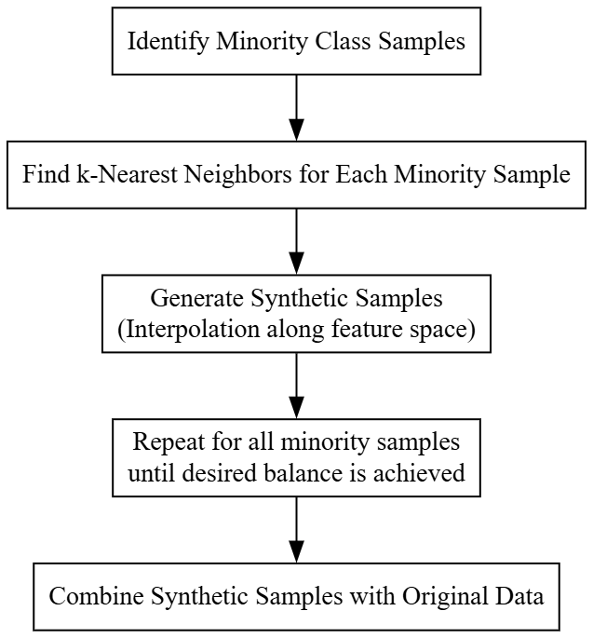
Fig.4.5: Internal operational workflow of SMOTE Data balancing.
Step-3: Generate Synthetic Samples
For each minority sample, SMOTE randomly selects one (or more) of its k-nearest neighbors. A synthetic sample is then generated along the line segment connecting the original sample and the chosen neighbor.
Step-4: Repeat Until Desired Balance
The process is repeated for all minority samples until the minority class reaches the desired number of examples, usually equal to the majority class. SMOTE ensures that the synthetic data is distributed across the minority feature space, preventing clustering of repeated points and improving classifier generalization.
Step-5: Integrate Synthetic Samples
Finally, all synthetic samples are combined with the original dataset to form a new, balanced dataset. The majority class remains untouched, while the minority class now has a richer, more diverse representation. This allows downstream models to learn better decision boundaries without being biased toward the majority class.
4.6 Model Building and training
Model building and training involves preprocessing both text and numeric features, including tokenization, lemmatization, and Numerical SBERT embedding extraction for textual data. Numeric features are combined with embeddings, and class imbalance is addressed using SMOTE. Separate models are trained for the two targets (fraud_flag and transaction_type) using Naive Bayes variants (Gaussian, Bernoulli, Multinomial) and Hist Gradient Boosting Classifier. Each model is trained on a train/test split, saved for reuse, and evaluated using accuracy, precision, recall, and F1-score. This approach ensures balanced, interpretable, and reproducible predictions on new data.
4.6.1 Multi-Output Naive Bayes Classifier
The Multi-Output Naive Bayes classifier is designed to handle multiple target variables within a single framework, training independent Naive Bayes models for each target while allowing for streamlined evaluation and model persistence. This approach is particularly effective when targets differ in type or distribution, enabling the use of Gaussian, Bernoulli, or Multinomial Naive Bayes depending on the data characteristics. Each target undergoes a full cycle of preparation, training, prediction, and evaluation, ensuring accurate modeling and performance tracking.
Step-1: Classifier Selection: The process begins with determining the type of Naive Bayes classifier suitable for the dataset. Depending on the nature of the features—continuous, binary, or count-based—the system selects Gaussian, Bernoulli, or Multinomial Naive Bayes, ensuring the statistical assumptions of the classifier align with the data characteristics. This step is crucial to achieve reliable conditional probability estimation.
Step-2: Feature and Label Preparation: Next, for each target variable, the system retrieves the corresponding feature set and encoded labels. If the features for a specific target are missing, that target is skipped, and an error is logged. This step ensures that only valid and complete datasets are used for training, preventing runtime errors and improving robustness.
Step-3: Data Splitting: Once the features and labels are prepared, the dataset for each target is divided into training and testing subsets, typically using an 80/20 split. This separation allows the model to learn patterns from the training data while reserving unseen data for unbiased evaluation.
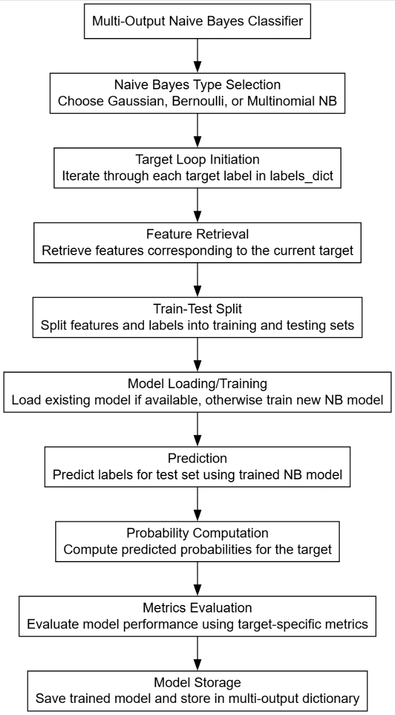
Fig. 4.6: Internal operation workflow of multioutput naïve baiyes classifier.
Step-4: Model Loading or Training: The system then checks whether a trained model for the target already exists on disk. If it does, the model is loaded to save computation time. If not, a new Naive Bayes model of the selected type is instantiated and trained on the training data, learning the conditional probabilities of each feature with respect to the target labels.
Step-5: Prediction and Probability Calculation: After training, the model generates predictions on the test set. It also attempts to compute predicted probabilities for each class. For classifiers that do not directly support probability outputs, logistic transformations of log-probabilities may be applied to approximate probabilities, allowing for threshold-based evaluation metrics.
Step-6: Metrics Evaluation: The predicted labels and probabilities are evaluated using target-specific metrics calculators. This step computes performance measures such as accuracy, precision, recall, and F1-score tailored to the target variable, enabling detailed insight into model effectiveness for each output.
Step-7: Model Persistence and Collection: Finally, the trained model is saved to disk for future use and added to a dictionary keyed by target variable name. This allows easy retrieval for inference or further analysis, completing the multi-output training workflow for all targets.
4.6.2 Multi-output Hist Gradient Boosting Classifier
The Hist Gradient Boosting Classifier is an ensemble learning algorithm that builds a series of decision trees sequentially, where each tree tries to correct the errors of the previous ones. Its internal operation leverages histogram-based binning of continuous features to speed up training and reduce memory usage. The model iteratively optimizes a loss function using gradient descent principles, combining weak learners into a strong predictive model.
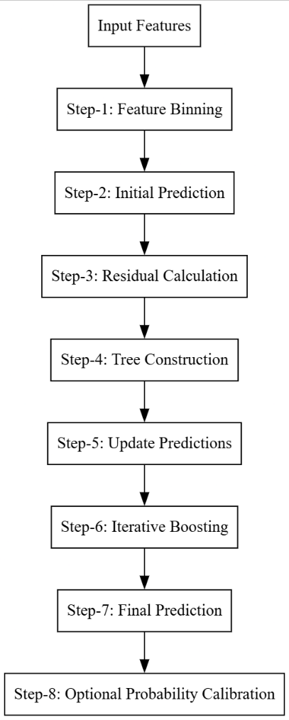
Fig. 4.7: Internal operational workflow of Multi-output Hist Gradient Boosting Classifier.
Step-1: Feature Binning
The model starts by discretizing continuous input features into bins (histograms). This reduces the number of unique feature values, allowing the algorithm to compute split points efficiently and accelerate tree construction.
Step-2: Initial Prediction
An initial prediction is generated for all training samples, typically using a simple constant (e.g., the average target value in regression or the prior probability in classification). This provides a baseline from which errors (residuals) are computed.
Step-3: Residual Calculation
For each training sample, the model calculates the pseudo-residuals, which are the gradients of the loss function with respect to the current prediction. These residuals quantify how far off the current predictions are from the true target values.
Step-4: Tree Construction
A decision tree is constructed to predict these residuals. The tree selects splits that minimize the loss function, using the binned feature representation to speed up the search for optimal splits. This tree acts as a weak learner in the ensemble.
Step-5: Update Predictions
The predictions from the newly grown tree are scaled by a learning rate and added to the existing predictions. This step incrementally improves the overall model, moving predictions closer to the actual targets.
Step-6: Iterative Boosting
Steps 3–5 are repeated for a predefined number of iterations (or until convergence). Each new tree focuses on correcting the errors of the combined previous trees, progressively refining the model.
Step-7: Final Prediction
After all boosting iterations, the ensemble of trees produces the final prediction. For classification, the outputs from all trees are combined (often using a softmax function) to generate class probabilities and the final class label.

CHAPTER 5
UML DIAGRAMS
Unified Modeling Language (UML) is a standardized visual language used to model, design, and document the architecture of software systems. It provides a set of graphical notations to represent the structure and behavior of a system, making complex systems easier to understand and communicate among developers, stakeholders, and business analysts.
Key Points About UML
- Standardized Notation: UML offers a universal set of symbols and diagrams that standardize how software systems are described, which helps teams speak the same language regardless of their background or the programming language they use.
- Types of Diagrams: UML includes various diagrams that can be categorized into two main types:
  - Structural Diagrams: These describe the static aspects of the system. Examples include Class Diagrams, Component Diagrams, and Deployment Diagrams.
  - Behavioral Diagrams: These focus on the dynamic aspects and interactions within the system. Examples include Use Case Diagrams, Sequence Diagrams, Activity Diagrams, and Collaboration Diagrams.
- System Documentation and Communication: UML serves as an effective tool for documenting system requirements, design decisions, and the overall architecture. It helps bridge the gap between technical and non-technical stakeholders by providing clear, visual representations of the system.
- Design and Analysis: By modeling different aspects of a system, UML enables developers to analyze and validate the design early in the development process. This can lead to better decision-making, reduced complexity, and improved system maintainability.
- Flexibility: UML is versatile and can be used across a wide range of applications, from small-scale projects to large, complex systems. It supports object-oriented design principles and can be adapted to various methodologies such as Agile or Waterfall.

5.1 Class Diagram
The Class Diagram defines the static structure of the system by showing its main classes, their attributes, methods, and relationships. For our secure image-hiding application, it illustrates components such as key management, encryption modules (ECC/ChaCha20), the steganography engine, compression/decompression, and the GUI. This view helps developers understand how data and functionality are organized, making it easier to plan implementations and identify class responsibilities.
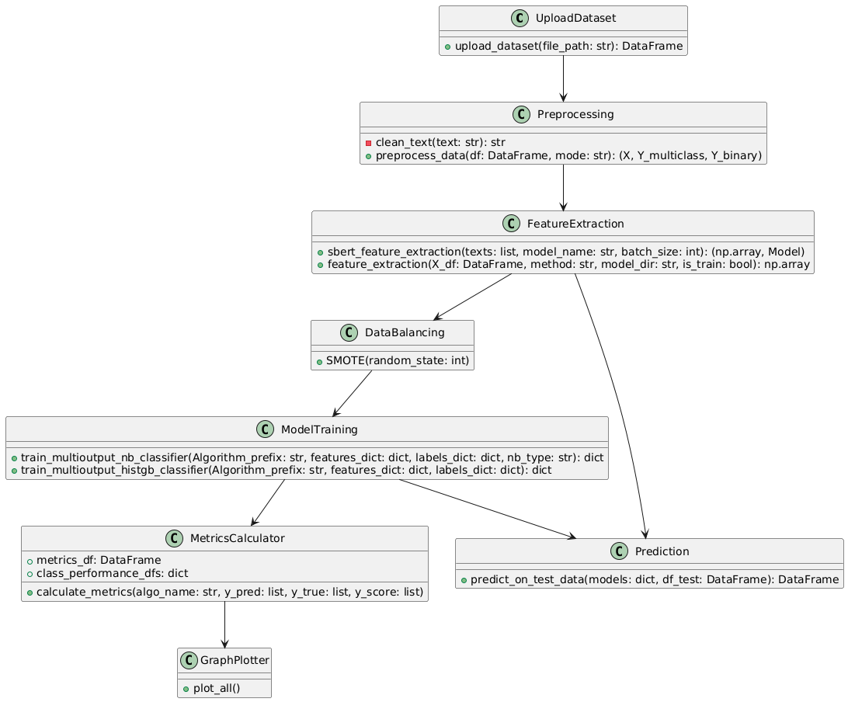
Fig. 5.1: Class diagram.
5.2 Use Case Diagram
The Use Case Diagram identifies the actors (users or external systems) and their goals (use cases) within the system. In our application, two primary actors—Sender and Receiver—interact with use cases such as “Upload Image,” “Encrypt & Embed,” “Compress & Send,” “Receive & Decompress,” “Extract & Decrypt,” and “Verify Integrity.” This view clarifies user interactions and helps define system requirements from the end-user perspective.
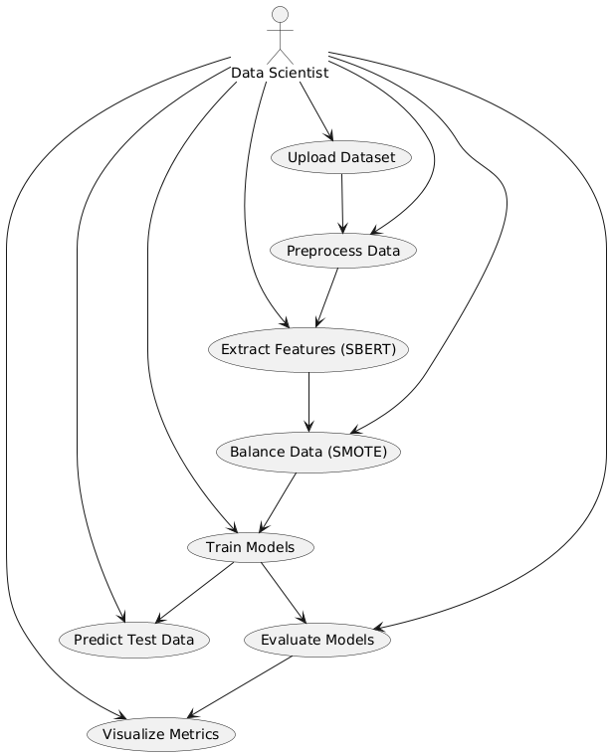
Fig. 5.2: Use case diagram.
5.3 Data Flow Diagram
The Data Flow Diagram (DFD) abstracts the movement of data through the system’s processes. At the highest level, it shows key processes—encryption/embedding, compression, transmission, decompression/extraction, decryption—along with data stores (keys, stego files) and external entities (Sender, Receiver). This view makes it easy to see how information flows from input to output.
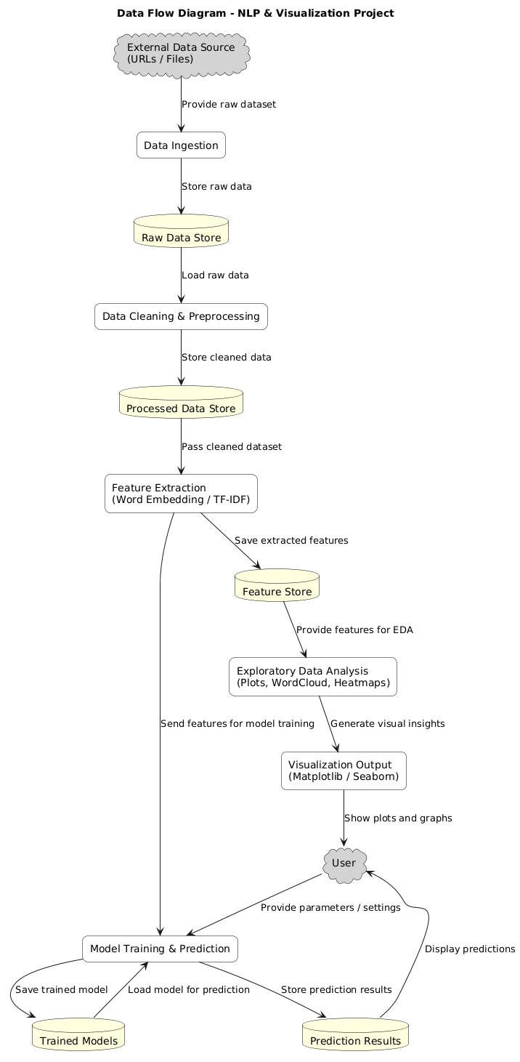
Fig. 5.3: Data flow diagram.
5.4 Deployment Diagram
The Deployment Diagram shows the physical arrangement of software components on hardware nodes. For this project, we depict a single User Workstation (client) hosting the application, and optional Remote Storage or File Transfer medium (e.g., cloud storage or SMTP server) for delivering compressed stego images. This view helps understand runtime environments, dependencies, and where each component resides
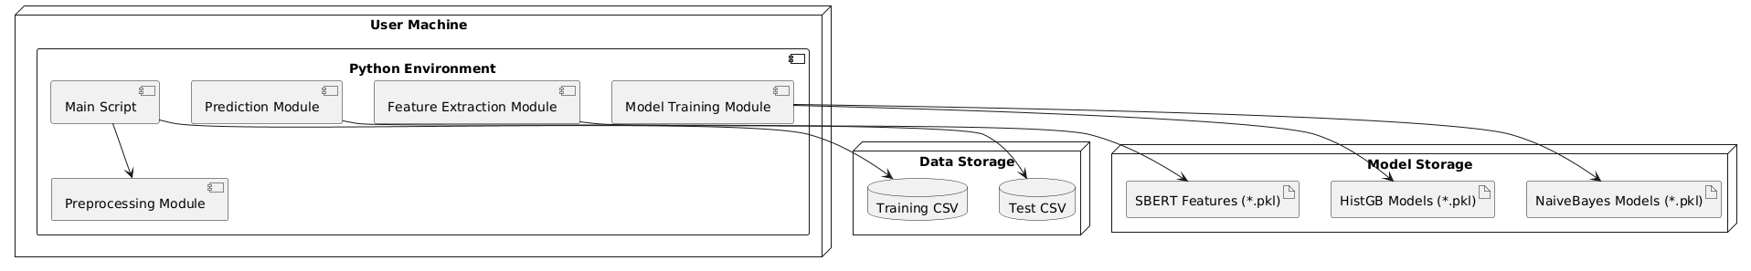
Fig. 5.4: Deployment diagram.
5.5 Component Diagram
The Component Diagram illustrates high-level modules (components) and their dependencies, focusing on how the system is built from interchangeable parts. For our application, components include the GUI, KeyManager, ECC/ChaCha20 encryption, StegoEngine, Compressor, and IntegrityChecker. This view helps developers see module boundaries, interface contracts, and where changes can be made without affecting other parts.
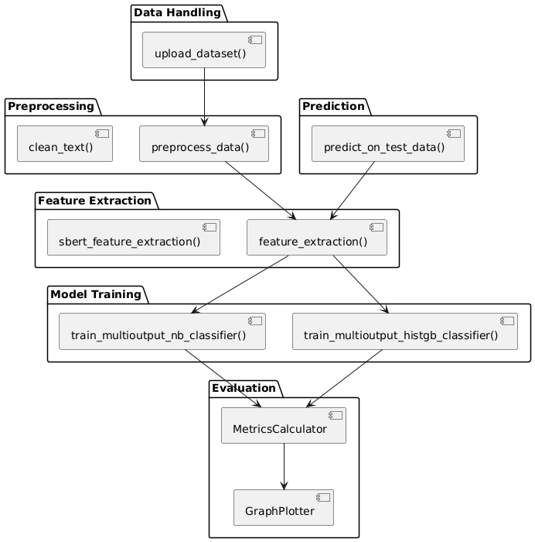
Fig. 5.5: Component diagram.
5.6 Collaboration Diagram
The Collaboration Diagram (also known as a Communication Diagram) shows how objects interact at runtime by sending messages to each other to accomplish a task. In our application, objects include instances of GUI, KeyManager, ECCModule/ChaChaModule, StegoEngine, Compressor, and IntegrityChecker. This view reveals the sequence of message exchanges—such as “getECCKeys,” “encrypt,” “embedBits,” “computeSHA”—that occur when the sender encrypts and embeds a message and when the receiver extracts and decrypts it.
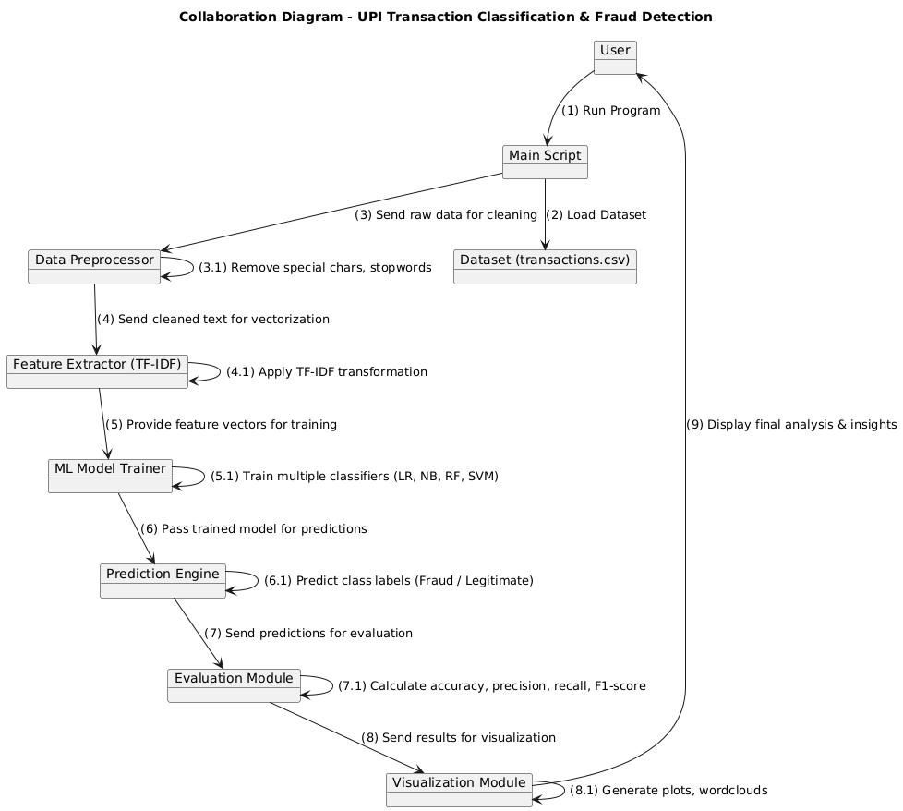
Fig. 5.6: Collaboration diagram.
5.7 Sequence Diagram
The Sequence Diagram illustrates the time-ordered interactions among objects during key scenarios: encrypting/embedding on the sender side and extracting/decrypting on the receiver side. It shows lifelines for the GUI, KeyManager, ECCModule/ChaChaModule, StegoEngine, Compressor, IntegrityChecker, and back to GUI. Messages such as getECCKeys(), encryptECC(), embedBits(), compressFile(), plus SHA computation and decryption calls appear in order. This view helps track the runtime flow of data and control between components.
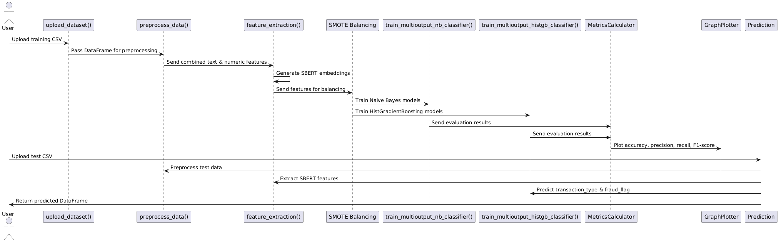
Fig. 5.7: Sequence diagram.

CHAPTER 6
SOFTWARE ENVIRONMENT
6.1 Software Requirements
Python is a high-level, interpreted programming language known for its simplicity and readability, which makes it a popular choice for beginners as well as experienced developers. Key features of Python include its dynamic typing, automatic memory management, and a rich standard library that supports a wide range of applications from web development to data science and machine learning. Its object-oriented approach and support for multiple programming paradigms allow developers to write clear, maintainable code. Python's extensive ecosystem of third-party packages further enhances its capabilities, enabling rapid development and prototyping across diverse fields.
Installation
First, download the appropriate installer from the official Python website (https://www.python.org/downloads/release/python-376/). For Windows users, run the executable installer and ensure to check the "Add Python to PATH" option during installation; for macOS and Linux, follow the respective package installation commands or use a package manager like Homebrew or apt-get. After installation, verify the setup by running python --version or python3 --version in your terminal or command prompt, which should display "Python 3.7.6." This version-specific installation supports all major functionalities and libraries compatible with Python 3.7.6, making it an excellent foundation for developing robust applications in areas such as data analysis, machine learning, and GUI development.
6.1.1 Python Packages
Below is a list of all the external Python packages (and key standard‐library modules) imported in the application, along with a brief explanation of each package’s role and how it is used in the project.
- Core Python & Utility Libraries
- os — for file and directory operations.
- re — for regular expressions in text cleaning.
- json — for reading/writing JSON data.
- pickle — for saving/loading Python objects.
- joblib — for saving/loading large model objects efficiently.
- numpy — for numerical computations.
- pandas — for data manipulation and analysis.
- collections (Counter) — for counting elements in lists or sequences.
- urllib.parse (urlparse) — for parsing URLs.
- scipy.special (expit) — for sigmoid function.
- Data Visualization
- matplotlib (matplotlib.pyplot) — for plotting graphs.
- seaborn — for statistical visualizations.
- wordcloud (WordCloud) — for generating word clouds.
- NLP (Natural Language Processing)
- nltk — for tokenization, stopwords, lemmatization, POS tagging, n-grams.
- gensim (gensim.downloader) — for downloading pre-trained embeddings.
- Machine Learning Preprocessing
- scikit-learn (sklearn.model_selection, sklearn.preprocessing) — for train-test split, label encoding, and model evaluation.
- imbalanced-learn (imblearn.over_sampling.SMOTE) — for balancing imbalanced datasets.
- Deep Learning (TensorFlow / Keras)
- tensorflow — for neural networks, text tokenization, padding sequences, and categorical conversion.
- Transformers (Hugging Face)
- transformers — for pre-trained transformer-based models like BERT, RoBERTa, XLNet.
- torch (PyTorch) — for deep learning and tensor computations.
- Progress Bar
- tqdm — for progress tracking in loops.
- Custom Modules
- metrics_calculator — user-defined module for calculating evaluation metrics.
- graphs — user-defined module for plotting metric-related graphs.
- Machine Learning Models
- scikit-learn (sklearn.naive_bayes) — for GaussianNB, BernoulliNB, MultinomialNB.
- scikit-learn (sklearn.ensemble.HistGradientBoostingClassifier) — for gradient boosting models.
6.2 Hardware Requirements
Python 3.7.6 can run efficiently on most modern systems with minimal hardware requirements. However, meeting the recommended specifications ensures better performance, especially for developers handling large-scale applications or computationally intensive tasks. By ensuring compatibility with hardware and operating system, can leverage the full potential of Python 3.7.6.
Processor (CPU) Requirements: Python 3.7.6 is a lightweight programming language that can run on various processors, making it highly versatile. However, for optimal performance, the following processor specifications are recommended:
- Minimum Requirement: 1 GHz single-core processor.
- Recommended: Dual-core or quad-core processors with a clock speed of 2 GHz or higher. Using a multi-core processor allows Python applications, particularly those involving multithreading or multiprocessing, to execute more efficiently.
Memory (RAM) Requirements: Python 3.7.6 does not demand excessive memory but requires adequate RAM for smooth performance, particularly for running resource-intensive applications such as data processing, machine learning, or web development.
- Minimum Requirement: 512 MB of RAM.
- Recommended: 4 GB or higher for general usage. For data-intensive operations, 8 GB or more is advisable.
Insufficient RAM can cause delays or crashes when handling large datasets or executing computationally heavy programs.
Storage Requirements: Python 3.7.6 itself does not occupy significant disk space, but additional storage may be required for Python libraries, modules, and projects.
- Minimum Requirement: 200 MB of free disk space for installation.
- Recommended: At least 1 GB of free disk space to accommodate libraries and dependencies.
Developers using Python for large-scale projects or data science should allocate more storage to manage virtual environments, datasets, and frameworks like TensorFlow or PyTorch.
Compatibility with Operating Systems: Python 3.7.6 is compatible with most operating systems but requires hardware that supports the respective OS. Below are general requirements for supported operating systems:
- Windows: 32-bit and 64-bit systems, Windows 7 or later.
- macOS: macOS 10.9 or later.
- Linux: Supports a wide range of distributions, including Ubuntu, CentOS, and Fedora.
The hardware specifications for the OS directly impact Python’s performance, particularly for modern software development.

CHAPTER 7
FUNCTIONAL AND NON-FUNCTIONAL REQUIREMENTS
7.1 Functional Requirements
The system is designed to classify UPI transactions into both fraud/non-fraud categories and transaction types such as bill payment, P2M, P2P, and recharge. It allows users to upload datasets in CSV format, which are then processed through a robust preprocessing pipeline involving null value handling, text cleaning, tokenization, lemmatization, and stopword removal. The system extracts meaningful features by combining numeric data with text embeddings generated using Sentence-BERT (SBERT). To address class imbalance, SMOTE is applied before training multiple classification models, including Naive Bayes and HistGradientBoostingClassifier, for multi-output prediction. The system supports model saving and loading for reuse, enabling fast predictions on new transaction data. Evaluation metrics such as accuracy, precision, recall, and F1-score are calculated, with results presented in both graphical and tabular formats to assist in decision-making.
- Dataset Upload
  - Allow users to upload transaction datasets (CSV format) for training or testing.
- Data Preprocessing
  - Fill missing values appropriately.
  - Extract numerical values from age groups.
  - Clean and normalize text (lowercasing, removing special characters, stopword removal, lemmatization).
- Feature Engineering
  - Combine all text columns into a single combined_text column.
  - Extract SBERT embeddings from combined_text.
  - Merge embeddings with numeric features.
- Data Balancing
  - Apply SMOTE to handle imbalanced datasets for both fraud detection and transaction type classification.
- Model Training
  - Train multiple models (GaussianNB, BernoulliNB, MultinomialNB, HistGradientBoostingClassifier).
  - Store trained models in the model directory for reuse.
- Prediction
  - Load stored models for fraud and transaction type classification.
  - Predict on new datasets and map encoded labels back to original labels.
- Performance Evaluation
  - Calculate performance metrics (accuracy, precision, recall, F1-score) for each model.
  - Generate visualizations of metric comparisons across models.
- Result Output
  - Produce prediction results with appended columns (Predicted_fraud_flag, Predicted_transaction_type).
  - Provide graphical and tabular summaries for end-user interpretation.
7.2 Non-Functional Requirements
The system should deliver high performance by efficiently processing datasets and training models without unnecessary delays, leveraging hardware acceleration where available. It must be scalable to support the integration of additional machine learning, deep learning, or transformer models without major code changes. The system should ensure usability through clear, modular code structures and well-documented functions, enabling data scientists and developers to easily operate and extend it. Maintainability is important, so the code should follow clean coding standards, allowing for updates and debugging with minimal effort. Portability must be ensured so that the project runs on different operating systems such as Windows, Linux, and macOS with minimal adjustments. Security measures should be implemented to prevent execution of malicious code when loading external datasets or models.
- Performance – Process datasets and train models efficiently, utilizing GPU acceleration if available.
- Scalability – Allow easy integration of new models, preprocessing steps, or evaluation metrics without major code changes.
- Usability – Maintain clear, modular, and well-documented code for easy use by data scientists and developers.
- Maintainability – Follow clean coding practices to simplify updates, debugging, and future enhancements.
- Portability – Ensure compatibility across multiple operating systems with minimal setup.
- Security – Protect against risks such as malicious code execution when loading external files or models.
7.3 System Study
The proposed system is technically feasible as it leverages widely available and well-supported Python libraries such as TensorFlow, Transformers, NLTK, and Scikit-learn, which are compatible with most modern computing environments. Since the project uses open-source tools, the economic feasibility is strong, with minimal costs involved other than potential investment in high-performance hardware like GPUs to speed up training. Operationally, the system is user-friendly for data scientists and machine learning practitioners familiar with Python, thanks to its modular structure and clear workflow. From a scheduling perspective, the system can be developed and deployed within a reasonable time frame, as the use of pre-built libraries and frameworks accelerates the development process. Legal feasibility is also ensured since all the libraries used are open-source and can be integrated without licensing conflicts, provided usage complies with respective licenses. Overall, the project is practical, affordable, and implementable within realistic time and resource constraints.
Feasibility Type | Description | Conclusion
Technical Feasibility | The project uses well-established libraries (TensorFlow, Transformers, Scikit-learn, SMOTE) that are compatible with modern hardware. Requires GPU support for faster SBERT processing but can run on CPU. | Feasible
Economic Feasibility | Open-source tools and frameworks minimize cost. No paid API usage. Development cost limited to system and storage requirements. | Feasible
Operational Feasibility | Easy integration into existing fraud detection workflows. Outputs are human-readable and suitable for business use. | Feasible
Legal Feasibility | Complies with data privacy laws as long as the dataset is anonymized before use. No restricted-license dependencies. | Feasible
Schedule Feasibility | Estimated development and testing time is manageable (4–6 weeks) based on available resources and skills. | Feasible

CHAPTER 8
SOURCE CODE
# ===============================
# Core Python Libraries
# ===============================
import os
import re
import json
import pickle
import joblib
import numpy as np
import pandas as pd
from collections import Counter
from urllib.parse import urlparse
from scipy.special import expit # Sigmoid function

# ===============================
# Data Visualization
# ===============================
import matplotlib.pyplot as plt
import seaborn as sns
from wordcloud import WordCloud

# ===============================
# NLP: NLTK & Gensim
# ===============================
import nltk
from nltk.corpus import stopwords
from nltk.tokenize import word_tokenize
from nltk.stem import WordNetLemmatizer
from nltk import pos_tag
from nltk.util import ngrams
import gensim.downloader as api

# ===============================
# Preprocessing & Modeling (Scikit-learn, imbalanced-learn)
# ===============================
from sklearn.model_selection import train_test_split
from sklearn.preprocessing import LabelEncoder
from imblearn.over_sampling import SMOTE

# ===============================
# Deep Learning (TensorFlow / Keras)
# ===============================
import tensorflow as tf
from tensorflow.keras.models import Sequential, Model, load_model
from tensorflow.keras.layers import Dense, Input, Embedding
from tensorflow.keras.preprocessing.text import Tokenizer
from tensorflow.keras.preprocessing.sequence import pad_sequences
from tensorflow.keras.utils import to_categorical

# ===============================
# Transformers (Hugging Face)
# ===============================
from transformers import (
AutoTokenizer, AutoModel,
RobertaTokenizer, RobertaModel,
BertTokenizer, BertForSequenceClassification,
XLNetTokenizer, XLNetForSequenceClassification
)
import torch
from torch.optim import AdamW

# ===============================
# Progress Bar
# ===============================
from tqdm import tqdm
from tqdm.auto import tqdm as tqdm_auto

# ===============================
# Custom Modules
# ===============================
from metrics_calculator import MetricsCalculator
from graphs import GraphPlotter

# ===============================
# Constants & Paths
# ===============================
MODEL_DIR = "model"
os.makedirs(MODEL_DIR, exist_ok=True)

fraud_labels = ["Normal", "Fraud"]
transaction_type_labels = ["Bill Payment", "P2M","P2P", "Recharge"]
metrics_calculator_wlb = MetricsCalculator(fraud_labels)
metrics_calculator_cg = MetricsCalculator(transaction_type_labels)
def upload_dataset(file_path):
"""Load the dataset from a CSV file"""
df = pd.read_csv(file_path,)
return df
path=r"UPI Transactions 2024 Dataset.csv"
df= upload_dataset(path)
df

tqdm.pandas()
label_encoders = {}

lemmatizer = WordNetLemmatizer()
stop_words = set(stopwords.words('english'))

def clean_text(text):
text = str(text).lower()
text = re.sub(r'[^a-z\s]', '', text)
tokens = text.split()
tokens = [lemmatizer.lemmatize(word) for word in tokens if word not in stop_words]
return ' '.join(tokens)

def preprocess_data(df=None, mode='train'):
print(f"[INFO] Mode: {mode}")
if df is None:
raise ValueError("A valid DataFrame must be provided.")

print("[INFO] Starting basic preprocessing...")

# Replace nulls appropriately
df = df.fillna({
col: 0 if pd.api.types.is_numeric_dtype(df[col]) else 'unknown'
for col in df.columns
})

# Extract age range columns and convert them
age_cols = ['sender_age_group', 'receiver_age_group']
for col in age_cols:
if col in df.columns:
df[f'{col}_min'] = df[col].apply(lambda x: int(x.split('-')[0]) if '-' in str(x) else 0)
df[f'{col}_max'] = df[col].apply(lambda x: int(x.split('-')[1]) if '-' in str(x) else 0)
df.drop(columns=[col for col in age_cols if col in df.columns], inplace=True)

# Text preprocessing
text_columns = df.select_dtypes(include='object').columns.tolist()

# Remove target columns from text preprocessing
targets = ['transaction_type', 'fraud_flag']
text_columns = [col for col in text_columns if col not in targets]

print(f"[INFO] Applying NLP preprocessing on: {text_columns}")
for col in text_columns:
df[col] = df[col].progress_apply(clean_text)

# Combine all text columns into one
df['combined_text'] = df[text_columns].agg(' '.join, axis=1)

# Create the final feature set excluding target columns
numeric_data = df.select_dtypes(include=[np.number])
X = pd.concat([df[['combined_text']], numeric_data], axis=1)

# Drop target columns from X if they still exist
X = X.drop(columns=[col for col in targets if col in X.columns], errors='ignore')

if mode == 'train':
Y_dict = {}
for target in targets:
if target in df.columns:
le = LabelEncoder()
Y_dict[target] = le.fit_transform(df[target].astype(str))
label_encoders[target] = le
return X, Y_dict.get('transaction_type'), Y_dict.get('fraud_flag')

elif mode == 'test':
return X

else:
raise ValueError("mode must be either 'train' or 'test'")

X, Y_multiclass,Y_binary = preprocess_data(df, mode='train')
Y_dict = {'fraud_flag': Y_binary, 'transaction_type': Y_multiclass}

def plot_target_distributions(Y_dict):
"""
Create count plots for each target column in Y_dict.

Parameters:
Y_dict (dict): Dictionary where keys are target column names and values are encoded label arrays.
"""
# Convert to DataFrame for easy plotting
y_df = pd.DataFrame(Y_dict)

# Plot each column
for col in y_df.columns:
plt.figure(figsize=(6, 4))
sns.countplot(x=y_df[col])
plt.title(f'Class Distribution: {col}')
plt.xlabel('Class')
plt.ylabel('Count')
plt.tight_layout()
plt.show()
plot_target_distributions(Y_dict)

X

def sbert_feature_extraction(texts, model_name='sentence-transformers/all-MiniLM-L6-v2', batch_size=32):
"""Extract SBERT features from texts with tqdm progress bar."""
tokenizer = AutoTokenizer.from_pretrained(model_name)
model = AutoModel.from_pretrained(model_name)
model.eval()

all_embeddings = []

for i in tqdm(range(0, len(texts), batch_size), desc="Extracting SBERT embeddings"):
batch_texts = texts[i:i+batch_size]
encoded_input = tokenizer(batch_texts, padding=True, truncation=True, return_tensors='pt')

with torch.no_grad():
model_output = model(**encoded_input)

token_embeddings = model_output.last_hidden_state
attention_mask = encoded_input['attention_mask']
input_mask_expanded = attention_mask.unsqueeze(-1).expand(token_embeddings.size()).float()

sum_embeddings = torch.sum(token_embeddings * input_mask_expanded, dim=1)
sum_mask = input_mask_expanded.sum(dim=1)
embeddings = sum_embeddings / sum_mask

all_embeddings.append(embeddings.cpu().numpy())

X = np.vstack(all_embeddings)
return X, model

def feature_extraction(X_df, method='Numerical_SBERT', model_dir='model', is_train=True):
x_file = os.path.join(model_dir, f'X_{method}.pkl')
print(f"[INFO] Feature extraction method: {method}, Train mode: {is_train}")
model_name = 'sentence-transformers/all-mpnet-base-v2'

# Extract the text column
text_data = X_df['combined_text'].tolist()

if is_train:
if os.path.exists(x_file):
print(f"[INFO] Loading cached features from {x_file}")
X = joblib.load(x_file)
else:
print("[INFO] Computing SBERT features...")
X, model = sbert_feature_extraction(text_data, model_name=model_name)
joblib.dump(X, x_file)
else:
print("[INFO] Computing SBERT features for test...")
X, model = sbert_feature_extraction(text_data, model_name=model_name)

return X

features = feature_extraction(X, method='Numerical_SBERT',is_train=True)
smote = SMOTE(random_state=42)
features_smoted = {}
labels_smoted = {}

for i, (key, y) in enumerate(Y_dict.items(), start=1):
X_resampled, y_resampled = smote.fit_resample(features, y)
features_smoted[f'features{i}'] = X_resampled
labels_smoted[f'Y{i}'] = y_resampled
print(f"Balanced '{key}' class: features{i}.shape = {X_resampled.shape}, Y{i}.shape = {y_resampled.shape}")

features_dict = {
'fraud_flag': features_smoted['features1'],
'transaction_type': features_smoted['features2']
}

labels_dict = {
'fraud_flag': labels_smoted['Y1'],
'transaction_type': labels_smoted['Y2']
}
from sklearn.naive_bayes import GaussianNB, BernoulliNB, MultinomialNB

def train_multioutput_nb_classifier(Algorithm_prefix, features_dict, labels_dict, nb_type='gaussian'):
nb_models = {}

NB_CLASSIFIERS = {
'gaussian': GaussianNB,
'bernoulli': BernoulliNB,
'multinomial': MultinomialNB,
}

if nb_type not in NB_CLASSIFIERS:
raise ValueError(f"Invalid nb_type '{nb_type}'. Must be one of {list(NB_CLASSIFIERS.keys())}.")

NBClass = NB_CLASSIFIERS[nb_type]

for target_name, y_encoded in labels_dict.items():
features = features_dict.get(target_name)

if features is None:
print(f"[ERROR] No features found for target: {target_name}")
continue

model_path = f"model/{Algorithm_prefix}_{target_name}_{nb_type}nb_model.pkl"
algo_name = f"{Algorithm_prefix} {nb_type.capitalize()}NB [{target_name}]"

X_train, X_test, y_train, y_test = train_test_split(features, y_encoded, test_size=0.2, random_state=42)

if os.path.exists(model_path):
print(f"Loading existing {nb_type.capitalize()}NB model for {target_name}...")
nb_model = joblib.load(model_path)
else:
print(f"Training {nb_type.capitalize()}NB for target: {target_name}...")
nb_model = NBClass()
nb_model.fit(X_train, y_train)
joblib.dump(nb_model, model_path)

y_pred = nb_model.predict(X_test)

# Get predicted probabilities
try:
y_score = nb_model.predict_proba(X_test)
except AttributeError:
try:
y_score = expit(nb_model.predict_log_proba(X_test).reshape(-1, 1))
except:
y_score = None

# Use target-specific metrics calculator
if target_name == "fraud_flag":
metrics_calculator_wlb.calculate_metrics(algo_name, y_pred, y_test, y_score)
elif target_name == "transaction_type":
metrics_calculator_cg.calculate_metrics(algo_name, y_pred, y_test, y_score)
else:
print(f"No metrics_calculator defined for: {target_name}")

nb_models[target_name] = nb_model

return nb_models

features_dict_positive = {k: np.abs(v) for k, v in features_dict.items()}
GNB_MODELS = train_multioutput_nb_classifier("Numerical BERT", features_dict_positive, labels_dict, nb_type='gaussian')
features_dict_positive = {k: np.abs(v) for k, v in features_dict.items()}
GNB_MODELS = train_multioutput_nb_classifier("Numerical BERT", features_dict_positive, labels_dict, nb_type='bernoulli')
features_dict_positive = {k: np.abs(v) for k, v in features_dict.items()}
GNB_MODELS = train_multioutput_nb_classifier("Numerical BERT", features_dict_positive, labels_dict, nb_type='multinomial')
from sklearn.ensemble import HistGradientBoostingClassifier
def train_multioutput_histgb_classifier(Algorithm_prefix, features_dict, labels_dict):
histgb_models = {}

for target_name, y_encoded in labels_dict.items():
features = features_dict.get(target_name)

if features is None:
print(f"[ERROR] No features found for target: {target_name}")
continue

model_path = f"model/{Algorithm_prefix}_{target_name}_histgb_model.pkl"
algo_name = f"{Algorithm_prefix} HGB [{target_name}]"

X_train, X_test, y_train, y_test = train_test_split(features, y_encoded, test_size=0.2, random_state=42)

if os.path.exists(model_path):
print(f"Loading existing HistGradientBoostingClassifier model for {target_name}...")
histgb = joblib.load(model_path)
else:
print(f"Training HistGradientBoostingClassifier for target: {target_name}...")
histgb = HistGradientBoostingClassifier()
histgb.fit(X_train, y_train)
joblib.dump(histgb, model_path)

y_pred = histgb.predict(X_test)

# Try getting predicted probabilities
try:
y_score = histgb.predict_proba(X_test)
except AttributeError:
try:
y_score = expit(histgb.decision_function(X_test).reshape(-1, 1))
except:
y_score = None

# Use target-specific metrics calculator
if target_name == "fraud_flag":
metrics_calculator_wlb.calculate_metrics(algo_name, y_pred, y_test, y_score)
elif target_name == "transaction_type":
metrics_calculator_cg.calculate_metrics(algo_name, y_pred, y_test, y_score)
else:
print(f"No metrics_calculator defined for: {target_name}")

histgb_models[target_name] = histgb

return histgb_models

histgb_models = train_multioutput_histgb_classifier("Numerical BERT", features_dict, labels_dict)

# Plot for Career Growth
graph_plotter_cg = GraphPlotter(metrics_calculator_cg.metrics_df, metrics_calculator_cg.class_performance_dfs)
graph_plotter_cg.plot_all()
# Plot for Job Security
graph_plotter_wlb = GraphPlotter(metrics_calculator_wlb.metrics_df, metrics_calculator_wlb.class_performance_dfs)
graph_plotter_wlb.plot_all()
melted_df_wlb = metrics_calculator_wlb.metrics_df[['Algorithm', 'Accuracy', 'Precision', 'Recall', 'F1-Score']].copy()
melted_df_wlb = melted_df_wlb.round(3)
melted_df_wlb
melted_df_cg = metrics_calculator_cg.metrics_df[['Algorithm', 'Accuracy', 'Precision', 'Recall', 'F1-Score']].copy()
melted_df_cg = melted_df_cg.round(3)
melted_df_cg

test_path=r"Test_data.csv"
df_test1= upload_dataset(test_path)
df_test1
# Initialize result DataFrame
df_result = df_test1.copy()

df_test = preprocess_data(df_test1, mode='test')
df_test
features_test = feature_extraction(df_test,method='Numerical SBERT',is_train=None)
fraud_labels = ["Normal", "Fraud"]
transaction_type_labels = ["Bill Payment", "P2M","P2P", "Recharge"]

features_test = feature_extraction(df_test,method='Numerical SBERT',is_train=None)
# Loop over each target
for target in ['transaction_type', 'fraud_flag']:

# Predict using the model
y_pred = histgb_models[target].predict(features_test)
print(y_pred)
# Fix label encoder if needed
if target == 'transaction_type':
label_encoders[target].classes_ = np.array(transaction_type_labels)
elif target == 'fraud_flag':
label_encoders[target].classes_ = np.array(fraud_labels)

# Inverse transform to get original string labels
mapped_labels = label_encoders[target].inverse_transform(y_pred)

# Add prediction column
df_result[f'Predicted_{target}'] = mapped_labels

# Final output
df_result

CHAPTER 9
RESULTS AND DISCUSSION
9.1 Implementation description

CHAPTER 10
CONCLUSION AND FUTURE SCOPE
They successfully demonstrates a robust NLP and machine learning–driven solution for multi-output classification of UPI transactions, focusing on both fraud detection and transaction type categorization. By leveraging advanced text preprocessing techniques, Sentence-BERT embeddings, and effective handling of class imbalance using SMOTE, the system achieves high predictive performance across multiple algorithms, including Naive Bayes variants and HistGradientBoostingClassifier. The modular structure of the code ensures that each stage—data preprocessing, feature extraction, model training, and evaluation—remains independent and reusable. The integration of graphical and tabular performance reports provides clarity for analysts and decision-makers, enabling them to assess model reliability and accuracy effectively. Overall, the system offers a scalable, adaptable, and technically sound foundation for real-world applications in the domain of digital payment security.

Future Scope
The system can be further enhanced to increase its accuracy, adaptability, and usability for broader applications. In the future, deep learning–based architectures such as Transformers fine-tuned on domain-specific transaction data can be incorporated for improved text understanding. Real-time streaming support can be implemented to allow live monitoring of UPI transactions, ensuring instant fraud detection and prevention. Integration with blockchain technology could improve data integrity and transparency in the fraud detection pipeline. Additionally, explainable AI (XAI) modules could be added to make model decisions more interpretable for auditors and compliance teams. The current system can also be extended to support multi-lingual transaction descriptions, allowing it to cater to diverse user bases across regions. Lastly, deployment as a secure web or cloud-based service would allow financial institutions to adopt it at scale while ensuring data privacy and compliance with financial regulations.

REFERENCE
- Chang, V.; Doan, L.M.T.; Di Stefano, A.; Sun, Z.; Fortino, G. Digital payment fraud detection methods in digital ages and Industry 4.0. Comput. Electr. Eng. 2022, 100, 107734.
- Li, A.; Pandey, B.; Hooi, C.F.; Pileggi, L. Dynamic Graph-Based Anomaly Detection in the Electrical Grid. IEEE Trans. Power Syst. 2022, 37, 3408–3422.
- Ali, A.; Razak, S.A.; Othman, S.H.; Eisa, T.A.E.; AI-Dhaqm, A.; Nasser, M.; Elhassan, T.; Elshafie, H.; Saif, A. Financial Fraud Detection Based on Machine Learning: A Systematic Literature Review. Appl. Sci. 2022, 12, 9637.
- Khando, K.; Islam, M.S.; Gao, S. The Emerging Technologies of Digital Payments and Associated Challenges: A Systematic Literature Review. Future Internet 2022, 15, 21.
- Alsenaani, K. Fraud Detection in Financial Services using Machine Learning. Master’s Thesis, RIT 1 Lomb Memorial Dr, Rochester, NY, USA, 2022.
- Ms. Kishori Dhanaji Kadam, Ms. Mrunal Rajesh Omanna, Ms. Sakshi Sunil Neje, Ms. Shraddha Suresh Nandai. “Online Transactions Fraud Detection using Machine Learning” Volume 5, Issue 6 June 2023, pp: 545-DOI Link:https://doi.org/10.22214/ijraset.2023.57551
- Chang V, Ali B, Golightly L, Ganatra MA, Mohamed M. Investigating Credit Card Payment Fraud with Detection Methods Using Advanced Machine Learning. Information. 2024; 15(8):478. https://doi.org/10.3390/info15080478
- Ali A, Abd Razak S, Othman SH, Eisa TAE, Al-Dhaqm A, Nasser M, Elhassan T, Elshafie H, Saif A. Financial Fraud Detection Based on Machine Learning: A Systematic Literature Review. Applied Sciences. 2022; 12(19):9637. https://doi.org/10.3390/app12199637
- AbouGrad H, Sankuru L. Online Banking Fraud Detection Model: Decentralized Machine Learning Framework to Enhance Effectiveness and Compliance with Data Privacy Regulations. Mathematics. 2025; 13(13):2110. https://doi.org/10.3390/math13132110
- Abbassi H, El Mendili S, Gahi Y. Adaptive, Privacy-Enhanced Real-Time Fraud Detection in Banking Networks Through Federated Learning and VAE-QLSTM Fusion. Big Data and Cognitive Computing. 2025; 9(7):185. https://doi.org/10.3390/bdcc9070185
- Binsawad M. Enhanced Financial Fraud Detection Using an Adaptive Voted Perceptron Model with Optimized Learning and Error Reduction. Electronics. 2025; 14(9):1875. https://doi.org/10.3390/electronics14091875
- Abbassi H, El Mendili S, Gahi Y. Adaptive, Privacy-Enhanced Real-Time Fraud Detection in Banking Networks Through Federated Learning and VAE-QLSTM Fusion. Big Data and Cognitive Computing. 2025; 9(7):185. https://doi.org/10.3390/bdcc9070185
- Oztemel E, Isik M. A Systematic Review of Intelligent Systems and Analytic Applications in Credit Card Fraud Detection. Applied Sciences. 2025; 15(3):1356. https://doi.org/10.3390/app15031356
- Yaseen H, Al-Amarneh A. Adoption of Artificial Intelligence-Driven Fraud Detection in Banking: The Role of Trust, Transparency, and Fairness Perception in Financial Institutions in the United Arab Emirates and Qatar. Journal of Risk and Financial Management. 2025; 18(4):217. https://doi.org/10.3390/jrfm18040217
- Sun Q, Tang T, Chai H, Wu J, Chen Y. Boosting Fraud Detection in Mobile Payment with Prior Knowledge. Applied Sciences. 2021; 11(10):4347. https://doi.org/10.3390/app11104347
- Sathupadi K, Achar S, Bhaskaran SV, Faruqui N, Uddin J. BankNet: Real-Time Big Data Analytics for Secure Internet Banking. Big Data and Cognitive Computing. 2025; 9(2):24. https://doi.org/10.3390/bdcc9020024
- Ali A, Abd Razak S, Othman SH, Eisa TAE, Al-Dhaqm A, Nasser M, Elhassan T, Elshafie H, Saif A. Financial Fraud Detection Based on Machine Learning: A Systematic Literature Review. Applied Sciences. 2022; 12(19):9637. https://doi.org/10.3390/app12199637
- Chang V, Ali B, Golightly L, Ganatra MA, Mohamed M. Investigating Credit Card Payment Fraud with Detection Methods Using Advanced Machine Learning. Information. 2024; 15(8):478. https://doi.org/10.3390/info15080478
- Abbassi H, El Mendili S, Gahi Y. Adaptive, Privacy-Enhanced Real-Time Fraud Detection in Banking Networks Through Federated Learning and VAE-QLSTM Fusion. Big Data and Cognitive Computing. 2025; 9(7):185. https://doi.org/10.3390/bdcc9070185
- Li X, Chu L, Li Y, Xing Z, Ding F, Li J, Ma B. An Intelligent Financial Fraud Detection Support System Based on Three-Level Relationship Penetration. Mathematics. 2024; 12(14):2195. https://doi.org/10.3390/math12142195
- Theodorakopoulos L, Theodoropoulou A, Tsimakis A, Halkiopoulos C. Big Data-Driven Distributed Machine Learning for Scalable Credit Card Fraud Detection Using PySpark, XGBoost, and CatBoost. Electronics. 2025; 14(9):1754. https://doi.org/10.3390/electronics14091754
- AbouGrad H, Sankuru L. Online Banking Fraud Detection Model: Decentralized Machine Learning Framework to Enhance Effectiveness and Compliance with Data Privacy Regulations. Mathematics. 2025; 13(13):2110. https://doi.org/10.3390/math13132110
- Aljunaid SK, Almheiri SJ, Dawood H, Khan MA. Secure and Transparent Banking: Explainable AI-Driven Federated Learning Model for Financial Fraud Detection. Journal of Risk and Financial Management. 2025; 18(4):179. https://doi.org/10.3390/jrfm18040179
- Golightly L, Ganatra MA, Mohamed M. Investigating Credit Card Payment Fraud with Detection Methods Using Advanced Machine Learning. Information. 2024; 15(8):478. https://doi.org/10.3390/info15080478
- Abbassi H, El Mendili S, Gahi Y. Adaptive, Privacy-Enhanced Real-Time Fraud Detection in Banking Networks Through Federated Learning and VAE-QLSTM Fusion. Big Data and Cognitive Computing. 2025; 9(7):185. https://doi.org/10.3390/bdcc9070185

